**Sprint 4 Plan**

**Product Name:** SummarAIze

**Sprint Completion Date:** June 3rd, 2025

**Revision Number:** V1.1

**Revision Date:** June 2nd, 2025

**Scrum Meeting Times:** M - 9:15-9:30pm, W - 12:00-2pm, F - 9:30am - 10:30am (Meeting with TA)

**High-Level Goal:** Complete the overall basic set-up for the project, finalize main goals, and delegate tasks.

**Task Listing:**

* {3} User Story 4.1 [13]
  + **As an educator, I want to be able to create a visual representation so that I can make presentations so that complex concepts are simplified for students.**
    - Task 1: Put visuals in frontend (1 hr)
    - Task 2: Research and add API to generate images (2 hr)
    - Task 3: Research and use Python libraries to create videos (3 hr)
    - Task 4: Add animation over visuals (4 hr)
    - Task 5: Integrate any visual components with the voiceover (3 hr)
* {10} User story 4.2 [13]
  + **As a user, I want to generate a presentation for the contents of the research paper so that I can use it to communicate the information to others effectively.**
    - Task 1: Use Google Slides API (1 hr)
    - Task 2: Parse research paper structure to map to slide content (3 hr)
    - Task 3: Improve presentation themes (3 hr)
* {6} User story 4.3 [13]
  + **As a student, I need to download videos I previously generated so that I can reference them later.**
    - Task 1: Connect database (1 hr)
    - Task 2: Store videos in database (2 hr)
    - Task 3: Update frontend with download page (2 hr)
    - Task 4: Allow downloading from database through web app (3 hr)
    - Task 5: Deploy the website (5 hr)
* {7} User story 4.4 [13]
  + **As a user, I want to get suggestions for related research papers so that I can explore the topic further.**
    - Task 1: Parse through citations at the end of the paper (1 hr)
    - Task 2: Connect to API to fetch papers based on keywords (3 hrs)
    - Task 3: Update frontend to display suggestions (1 hr)
* **Total Estimated Hours: 50 hours**

Team Roles:

Koena: Project Owner, Developer

Ashton: Developer

Poojitha: Developer

Amisha: Developer

Nathan: Scrum Master, Developer

**Scrum Board:**

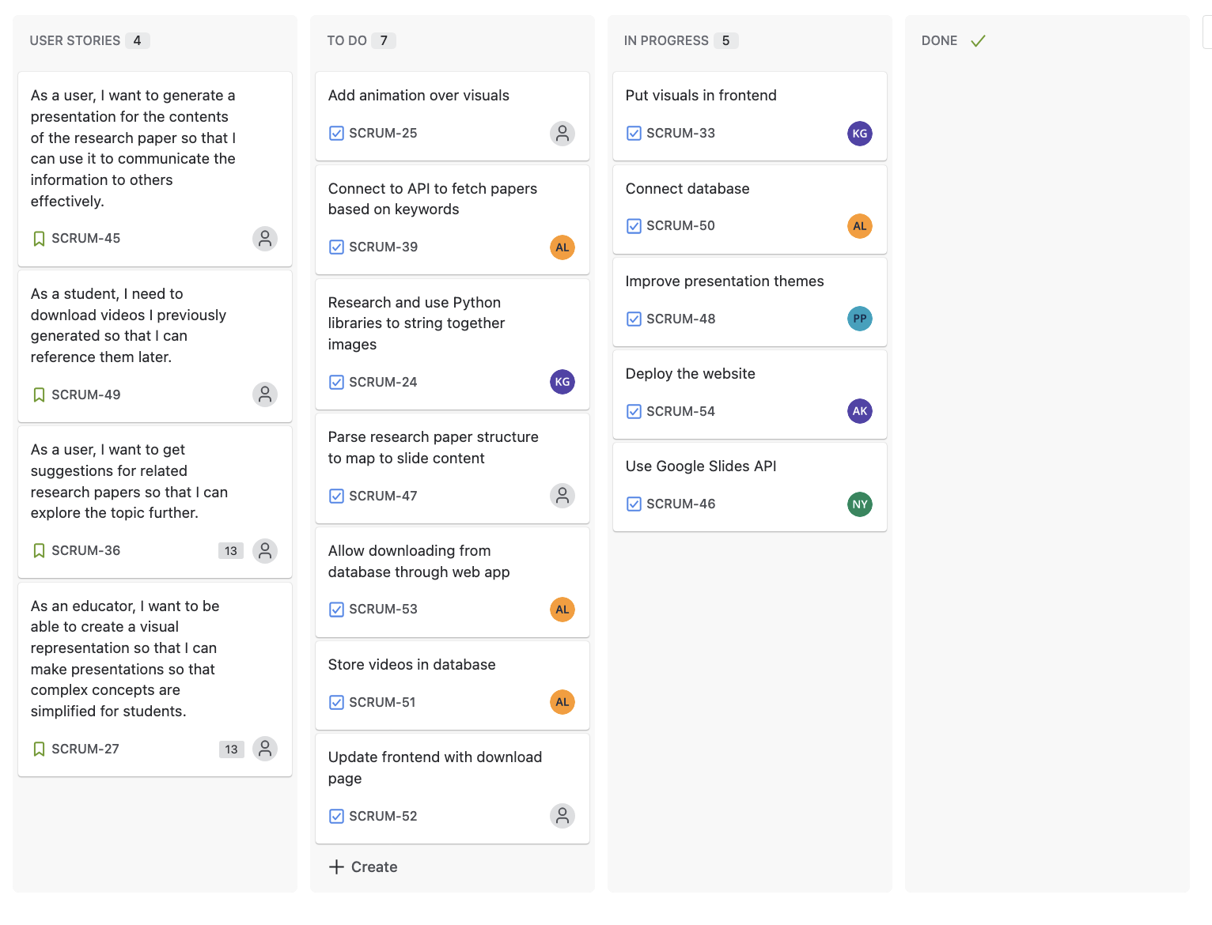

**Burn up Chart:**

